INDIVIDUAL VARIATION OF GROWTH AND FILTRATION RATES OF MUSSELS Mytilus Galloprovincialis Lam.

Irina Kazankova, Institute of Natural and Technical Systems RAS, ikazani@bk.ru

Elena Vasechkina, Marine Hydrophysical Institute RAS, vasechkina.elena@gmail.com

Research on individual variation of the filtration and growth rates of mussels was based both on the authors’ field and laboratory experiments and literature data analysis. High individual variability of these characteristics was recorded during the tests. The coefficient of variation grew up as the mean rate diminished. Under low specific growth rate the coefficient of variation (ratio of root-mean-square deviation to the sample mean) could exceed 100 %. Tests revealed the power-law relation of the coefficient of variation from the average for studied characteristics. That relation could be seen in filtration and growth rate charts; it was also true for estimates of production energy and metabolic costs. The exponent varied from -0.36 to -0.77. Individual growth rate variation of mussels was concluded to be an important criterion of the favorability of environmental conditions.

Key words: clearance rate, laboratory experiments, mariculture, Bivalvia

I. Introduction
Individual variation of living organisms can be regarded from different aspects: like an individual variation of a specimen, revealed in the process of its functioning and ontogenesis; like differences between specimens relatively close or genotypically identical or like manifestation of diverse differences between specimens of the same family, genus, and species in similar conditions. In the latter case, individual variation is an indefinite variation based on inherited differences between individuals which are essential for the evolutionary process [1].
The present paper is dedicated to the indefinite individual variation of some functional characteristics of mussels Mytilus galloprovincialis Lam., namely the growth and filtration rates. Physiological processes of mussels are known to depend on a lot of ambient conditions. M. galloprovincialis is an eurybiont that lives in various biotopes of the Black Sea and is widely distributed in seas of the world ocean. The unity and genetic diversity of a mussel population are provided by a long-distance horizontal transfer of its larvae by currents (at low temperatures they can stay in plankton up to 4 months [2]) and vertical dispersal due to upwelling and downwelling processes [3]. Nowadays the Black Sea population of M. galloprovincialis has essentially scaled down its biomass when compared to the 1970s and 1980s [4, 5]. Such climatic changes like stable increase of the mean water temperature, which will hardly differ in the next few decades, can have a negative effect on adaptive abilities of the population and its genetic diversity ensuring the evolutionary process. Within such outlook, evolution and selection studies of the Black Sea mussels obtain exceptional importance.
There are only a few works concerning individual variation of filtration rate, linear and weight rate of mussels [6 – 9]. In this study we investigated individual variation of the functional characteristics of mussels based on the literature data and our own observations.

II. Materials and methods
Individual variation of the growth rate
In 2008 and 2015 we carried out natural experiments to estimate individual linear and weight growth rates of mussels. Each experimental mussel was indexed by a metal stylet. We measured linear parameters of a specimen by the digital caliper and total wet weight by the laboratory balance «Sartorius». As an indicator of individual variation we used the coefficient of variation CV that was calculated as the ratio of the standard deviation to the average, in other words, the relative dispersion of measured growth rates.
In 2008 experiment mussels were located in a shallow-water layer at the top of Sevastopol Bay from June till December. We used juvenile mussels within the length range of 15-20 mm, which were taken from rope collectors of a mussel farm and placed in cages at the depth one meter. Every 20-40 days we measured the length of the shells and put mollusks back into the cages for further growth. At the same time new juvenile mussels within the length range 15-20 mm were placed in additional experimental cage to gather statistics on these fixed size mussels. In that way, during the experiment we obtained information about the monthly growth rate of the 15-20 mm size molluscs and larger mussels (20 – 50 mm). .
From June till November 2015 cages with mussels were located in Martynova Bay, which is near the Sevastopol Bay mouth. During that experiment we measured not only the length growth of the shell but also the height and the weight growth rate of every mussel. For the experiment we chose 120 mollusks from mussel farm collectors within the 15-20 mm length range. The sample was divided into six groups by 20 specimens in every group. Five groups were placed in meshed cages by 20 specimens in each. Mussels of the last group were placed separately, hereinafter we call them «isolated» mussels. Such division was made to study influence of aggregation on the growth rate. One more group of 20 isolated mussels within the length range of 18-21 mm was added in July. Linear size and weight of mussels were measured approximately once per month.
Individual variation of the filtration rate
Series of experiments were performed to measure the individual filtration rate of mussels, which was estimated by the amount of water cleared from particles per unit of time. Five samples of mollusks with similar length parameters were selected from natural populations. The size ranges within groups were: 12-16 mm (12 spc.), 17-18 mm (15 spc.), 18-25 mm (24 spc.), 22-23 mm (15 spc.) and 35-38 mm (10 spc.). Measurements of mussels’ filtration rate were repeated twice for each group. The specimens were placed by one in chambers of equal volume with sea-water containing food particles for one hour. To prepare the food suspension for mollusks we used microalgae Tetraselmis viridis which biomass was defined by optical density with the wave length 750 nm. Measurements of the optical density were made by the photoelectric colorimeter PC-3 in a 10 cm cuvette. Conversion from optical density (D750) to absolute dry weight of biomass D was realized by means of empirical coefficient equal to 0.0375 g∙l⁻¹∙unit of optical density⁻¹ [10] . The optical density of suspension was measured before and after the exposition, an increment of this characteristic was used to calculate the filtration rate of the mollusk. We derive expression for filtration rate calculation from the equation describing decrease of seston concentration in a chamber of volume V (l) containing mussels [11]:

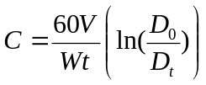,

Where C (l∙h⁻¹) – filtration rate, D₀ and D_{t} – initial and final seston concentration (g∙l⁻¹), t – time of exposition in minutes, W – weight of mussels (g). Water temperature in the experiment varied in a range 23 – 26 °С. Then we used data from [6, 8, 9] to analyze the published results of measurements of growth, filtration and oxygen consumption rates of mussels.

III. Results and discussion
During the experiments in 2008 growth rates of 15-20 mm mussels and bigger ones (20-50 mm) were approximately within the same range so we presented them on one figure (Fig. 1a). And on Fig. 1b one can see a power-law dependence of the coefficient of variation on the average growth rate calculated on these data. Extrapolating the data we can assume that if the average growth rate is more than 3.3 mm∙month⁻¹, the coefficient of variation will fall down to 30% and the sample will become homogeneous by this functional characteristic. This value matches multi-year annual average of the growth rate of juvenile mussels in Sevastopol Bay obtained in 2008 – 2014 [12]. In unfavorable periods of 2008 when the average growth rate of both big and small mussels slowed down to 1-2 mm∙month⁻¹ the coefficient of variation rose up to 60-78 %.

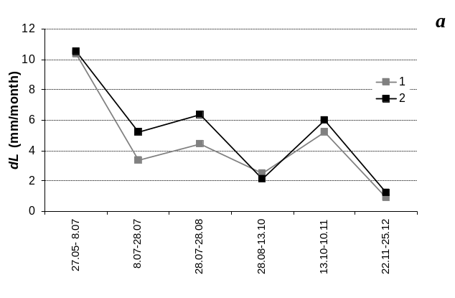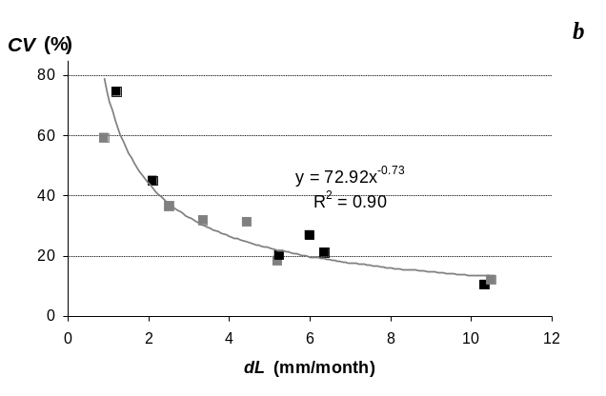
Fig. 1. Average linear growth rate of mussels in Sevastopol Bay in 2008. – а; dependence of the coefficient of variation from the average linear growth rate of mussels – b.
1 - 20-50 mm size group, 2 – 15-20 mm size group.

Fig. 2 demonstrates dependence of the coefficient of variation from the average linear and weight growth rates of mussels based on the results of experiments in Martynova Bay in 2015. It should be noted that morphometric features of mussels in the sample were distributed homogeneously, the coefficient of variation was below 5% for length, 8% for height and 17% for wet weight. In 2015 environment conditions for the mussel growth were worse than in 2008, so the average linear growth rate of the shells was less than 3.3 mm∙month⁻¹. Herewith, the coefficient of variation of studied characteristics in some periods could achieve 120%. During the experiment the samples were homogeneous (when the coefficient of variation was less than 30%) by the linear growth rate only in two or three of 26 cases and by the weight rate – in seven cases.

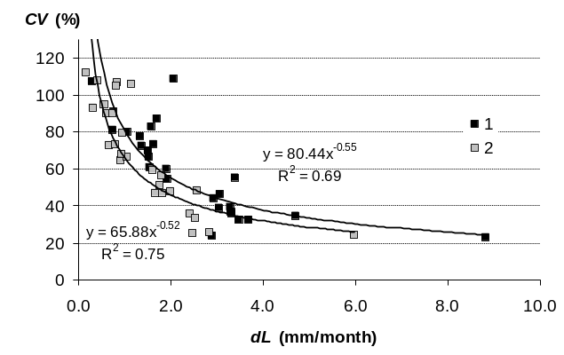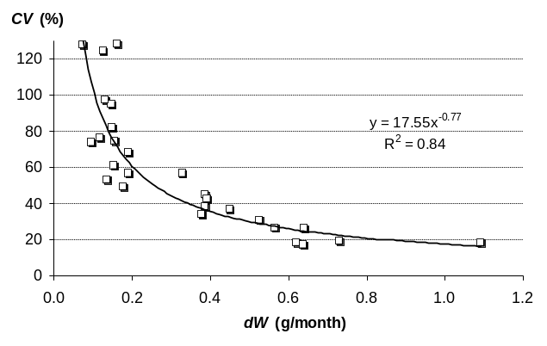
Fig. 2. The coefficient of variation as a function of: the average linear – а, and specific weight – b growth rates of mussels according to the natural experiments in Martynova Bay (June – November, 2015). 1, 2 – points for the growth rate in length and height respectively.

Results obtained during natural experiments in 2008 and 2015 helped us to trace an individual growth of different mussels. Fig. 3 demonstrates that some specimens remarkably slowed down their growing when the average growth rate of the sample increased and vice versa.

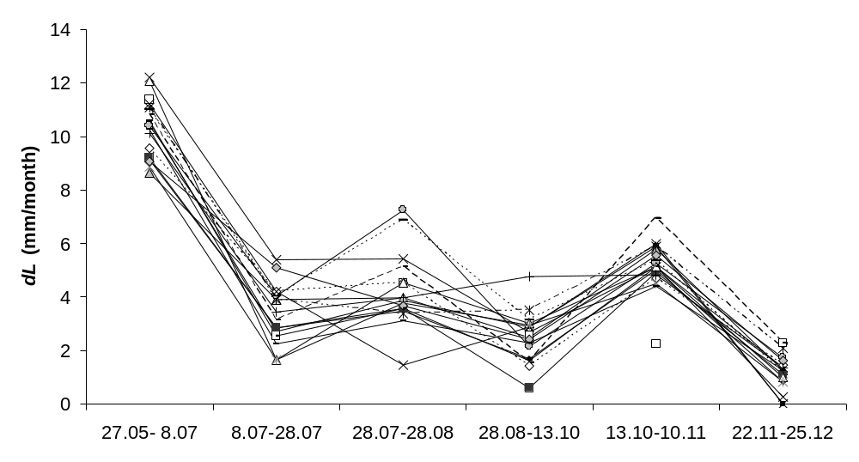

Fig. 3. Dynamic of mussels’ individual linear growth rate during the period June – December, 2008 (Sevastopol Bay).

On one hand, such changes of individual growth rates of mussels in clumps could have been explained by peculiarities of their positions that were changed at the end of every period of observations. On the other hand, comparison of mussels’ growth in 2015 has revealed that the opposite sign changes of the growth rate have been demonstrated both by isolated and aggregated mussels. Moreover, in some periods changes of growth with opposite sign were more strongly marked for isolated mussels (fig. 4).

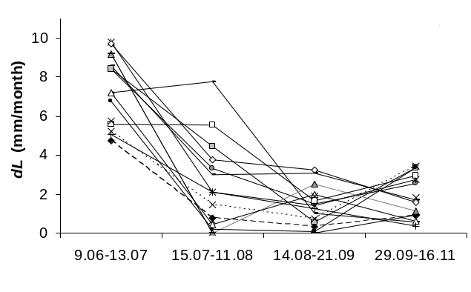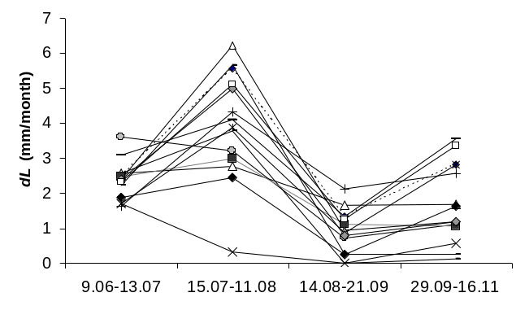
Fig. 4. Individual growth rate of isolated mussels – а, and mussels in clumps – b in 2015 (Sevastopol Bay).

Laboratory studies on filtration rates also prove that the coefficient of variation decreases when mean value of the characteristic increases. Results are presented on Fig. 5. The coefficient of variation of filtration rate in performed studies was generally more than 30% and could reach 120%. Such great variation of this characteristic was obviously the result of such unfavorable ambient conditions as high water temperature and high concentration of algae in suspension (0.015 – 0.017 g∙l⁻¹).

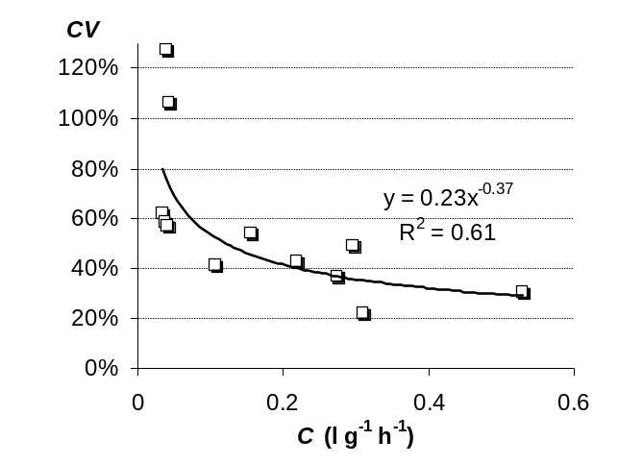
Fig. 5. Power-law relation between the coefficient of variation and the average specific filtration rate of mussels.

Similar power-law relations between variation coefficients and average values of the functional characteristics were obtained from the analysis of published results on specific filtration rate of Dreissena polymorpha mussels [8] and growth rates of 30 mm and 50 mm Mytilidae mussels presented in [6] (samples contained 200 spc. each). These data are displayed on Fig. 6.

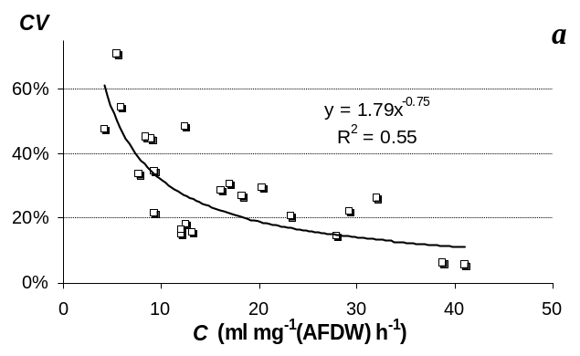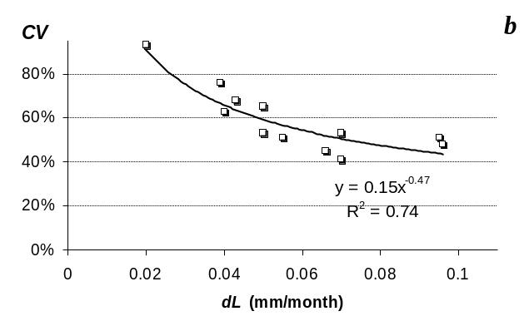

Fig. 6. Coefficients of variation as functions of: the average specific filtration rate (C) of D. рolymorpha [8] – a; the average linear growth rate of 30 mm and 50 mm mussels M. galloprovincialis [6] – b. AFDW - Ash-Free Dry Weight.

The paper [9] presents estimated statistic characteristics of M. edulis mussel energy balance components. Studied mussels were got from natural populations at Langesund Fjord in Norway. Four samples each containing 16 similar mollusks were brought to the laboratory from four biotopes with different level of pollution. Furthermore, four other samples were taken from experimental basins with different copper and hydrocarbons concentrations. All eight samples were tested in laboratory-based conditions to measure filtration rates, oxygen consumption rates and ammonium excretion rates in order to define energy balance components for mussels. Fig. 7 illustrates relations between the coefficients of variation and the averages for measured filtration rate (C), oxygen consumption rate (R) and ammonium excretion (E), calculated on the data from [9]. As one can see, the coefficient of variation for filtration in that experiment was the lowest, therefore experimental specimens differed in filtration activity less than in oxygen consumption rate or in ammonium excretion rate. Individual variation was especially demonstrative on energy balance productive component – the part of consumed energy used for mollusk’s growth (fig. 7d). At negative values of mean production in a sample the coefficient of variation reached 140%.

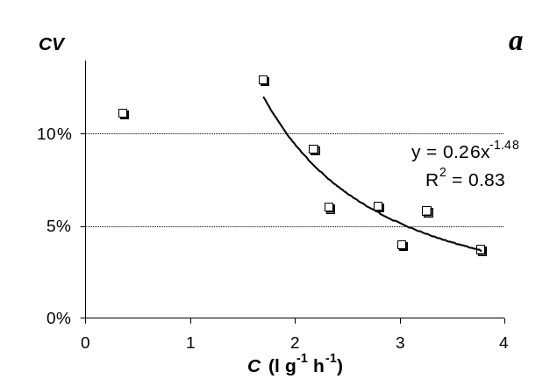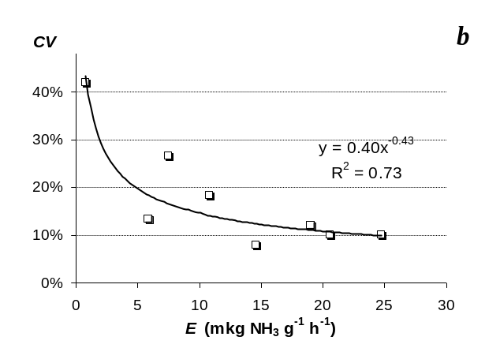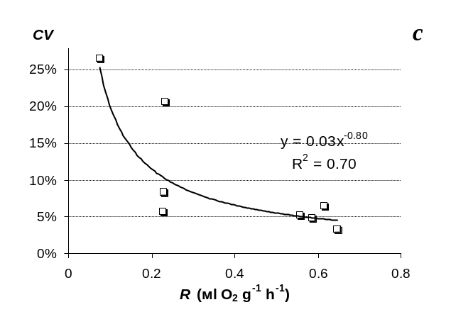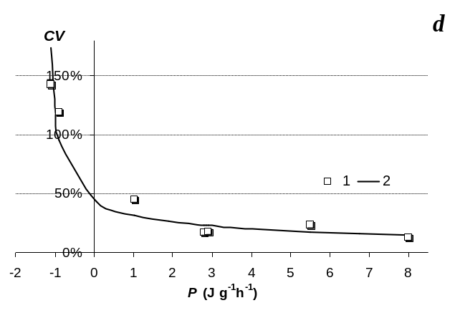
Fig. 7. The coefficient of variation as a function of the average for: filtration rate (C) – а; oxygen consumption rate (R) – b; ammonium excretion rate (E) – c; energy balance productive component of mussels (P) – d (based on data from [9]).

IV. Conclusion
Conducted experiments showed high individual variation of studied characteristics of M. galloprovincialis reaching 120% under low average values. We revealed power-law dependence of the coefficient of variation on average not only in filtration and growth rates data, but also in estimates of productive and metabolic energies. Individual variation level of mussels’ growth rate can indicate whether environment conditions are favorable for them. When the average rate decreases the sample becomes inhomogeneous in functional characteristics because individual variation rises sharply. It can be explained by the fact that under unfavorable conditions mussels with better adaptive abilities demonstrate comparatively high growth rate, whereas other mollusks slow down their growth or die out. When ambient conditions become favorable again, mollusks demonstrate similar high growth and filtration rates, so the sample becomes again homogeneous in functional characteristics of a specimen. This conclusion should be taken into account while planning field studies and experiments, selection studies and mathematical simulation of mussel farm functioning.

V. References
[1] Ch. Darwin, “On the Origin of Species by Means of Natural Selection, or the Preservation of Favoured Races in the Struggle for Life”, The translation from 6th ed. (London, 1872), Under the edit. of A.L. Takhtadzhyan, St Petersburg: Science, 1991.
[2] I. I. Kazankova, “Mytilus galloprovincialis Lam. settlements formation on artificial substrates at the southern and west-southern shores of the Crimea”, PhD thesis in biology, Institute of biology of the southern seas NAN of Ukraine, Sevastopol, 2006.
[3] I. I. Kazankova, “Peculiarities of dynamics of the Mytilus and Mytilaster settlement in relation to upwelling and downwelling at the southwestern coast of the Crimea (Black Sea)”, Ecologiya morya, 2000, № 51, pp. 35-39.
[4] N. M. Shurova, “Structurally functional organization of population of mussels Mytilus galloprovincialis of the Black Sea” Doctor of biological sciences thesis, Institute of biology of the southern seas NAS of Ukraine, Sevastopol, 2009, 26 p.
[5] M. A. Kovalyova, N. A. Boltachyova, N. C. Kostenko, “Long-term dynamics of a condition of settlements of Mytilidae on Rocks Kara Dag (Black Sea)”, Mor. Ekol. Jurn., 2012, vol. 11, № 2, pp. 39-44.
[6] N. S. Chelyadina, “Morphological, biochemical and chemical characteristics of the mussel Mytilus galloprovincialis Lam., cultivated in the Black Sea”, PhD dissertation in biology, Institute of biology of the southern seas NAS of Ukraine, Sevastopol, 2014, 142 p.
[7] E. F. Vasechkina, I. I. Kazankova, “Individual variability of functional characteristics of mussel Mytilus galloprovincialis Lam. in experiments”, Proc. of Conf. “Commercial invertebrates”, VIII all-russian scientific conference on trade invertebrates (Sept., 2-5, 2015, Kaliningrad), Kaliningrad, 2015, pp. 264-266.
[8] D. L. Fanslow, T. F. Nalepa, G. A. Lang “Filtration rates of the zebra mussel (Dreissena polymorpha) on natural seston from Saginaw Bay”, Lake Huron Journal of Great Lakes Research, 1995, vol. 21, pp. 489-500.
[9] J. Widdows, D. Johnson, “Physiological energetics of Mytilus edulis: Scope for Growth”, Mar. Ecol. Prog. Ser., 1988, vol. 46, pp. 113-121.
[10] A. B. Borovkov, R. G. Gevorgiz, “Efficiency of Spirulina platensis and Tetraselmis viridis when using various methods of cultivation”, Ecologiya morya, 2005, vol. 70, pp. 9-13.
[11] J. Coughlan, “The estimation of filtering rate from the clearance of suspensions” Marine Biol., 1969, vol. 2, pp. 356-358.
[12] I. I. Kazankova, “Growth of mussel Mytilus galloprovincialis Lam. near the Southern coast of the Crimea and in the Sevastopol bay in 2008 - 2012”, Sistemy kontrolya okruzhayuschey sredy, 2012, vol. 18, pp. 172-176.

